**Wild Watch Web**

|  |  |  |
| --- | --- | --- |
| **Team Members** | | |
| **Name** | **Student Number** | **E-mail address** |
| **Aly Shmahell** | *258912* | *aly.shmahell@student.univaq.it* |

# Public Front End (Home Page):

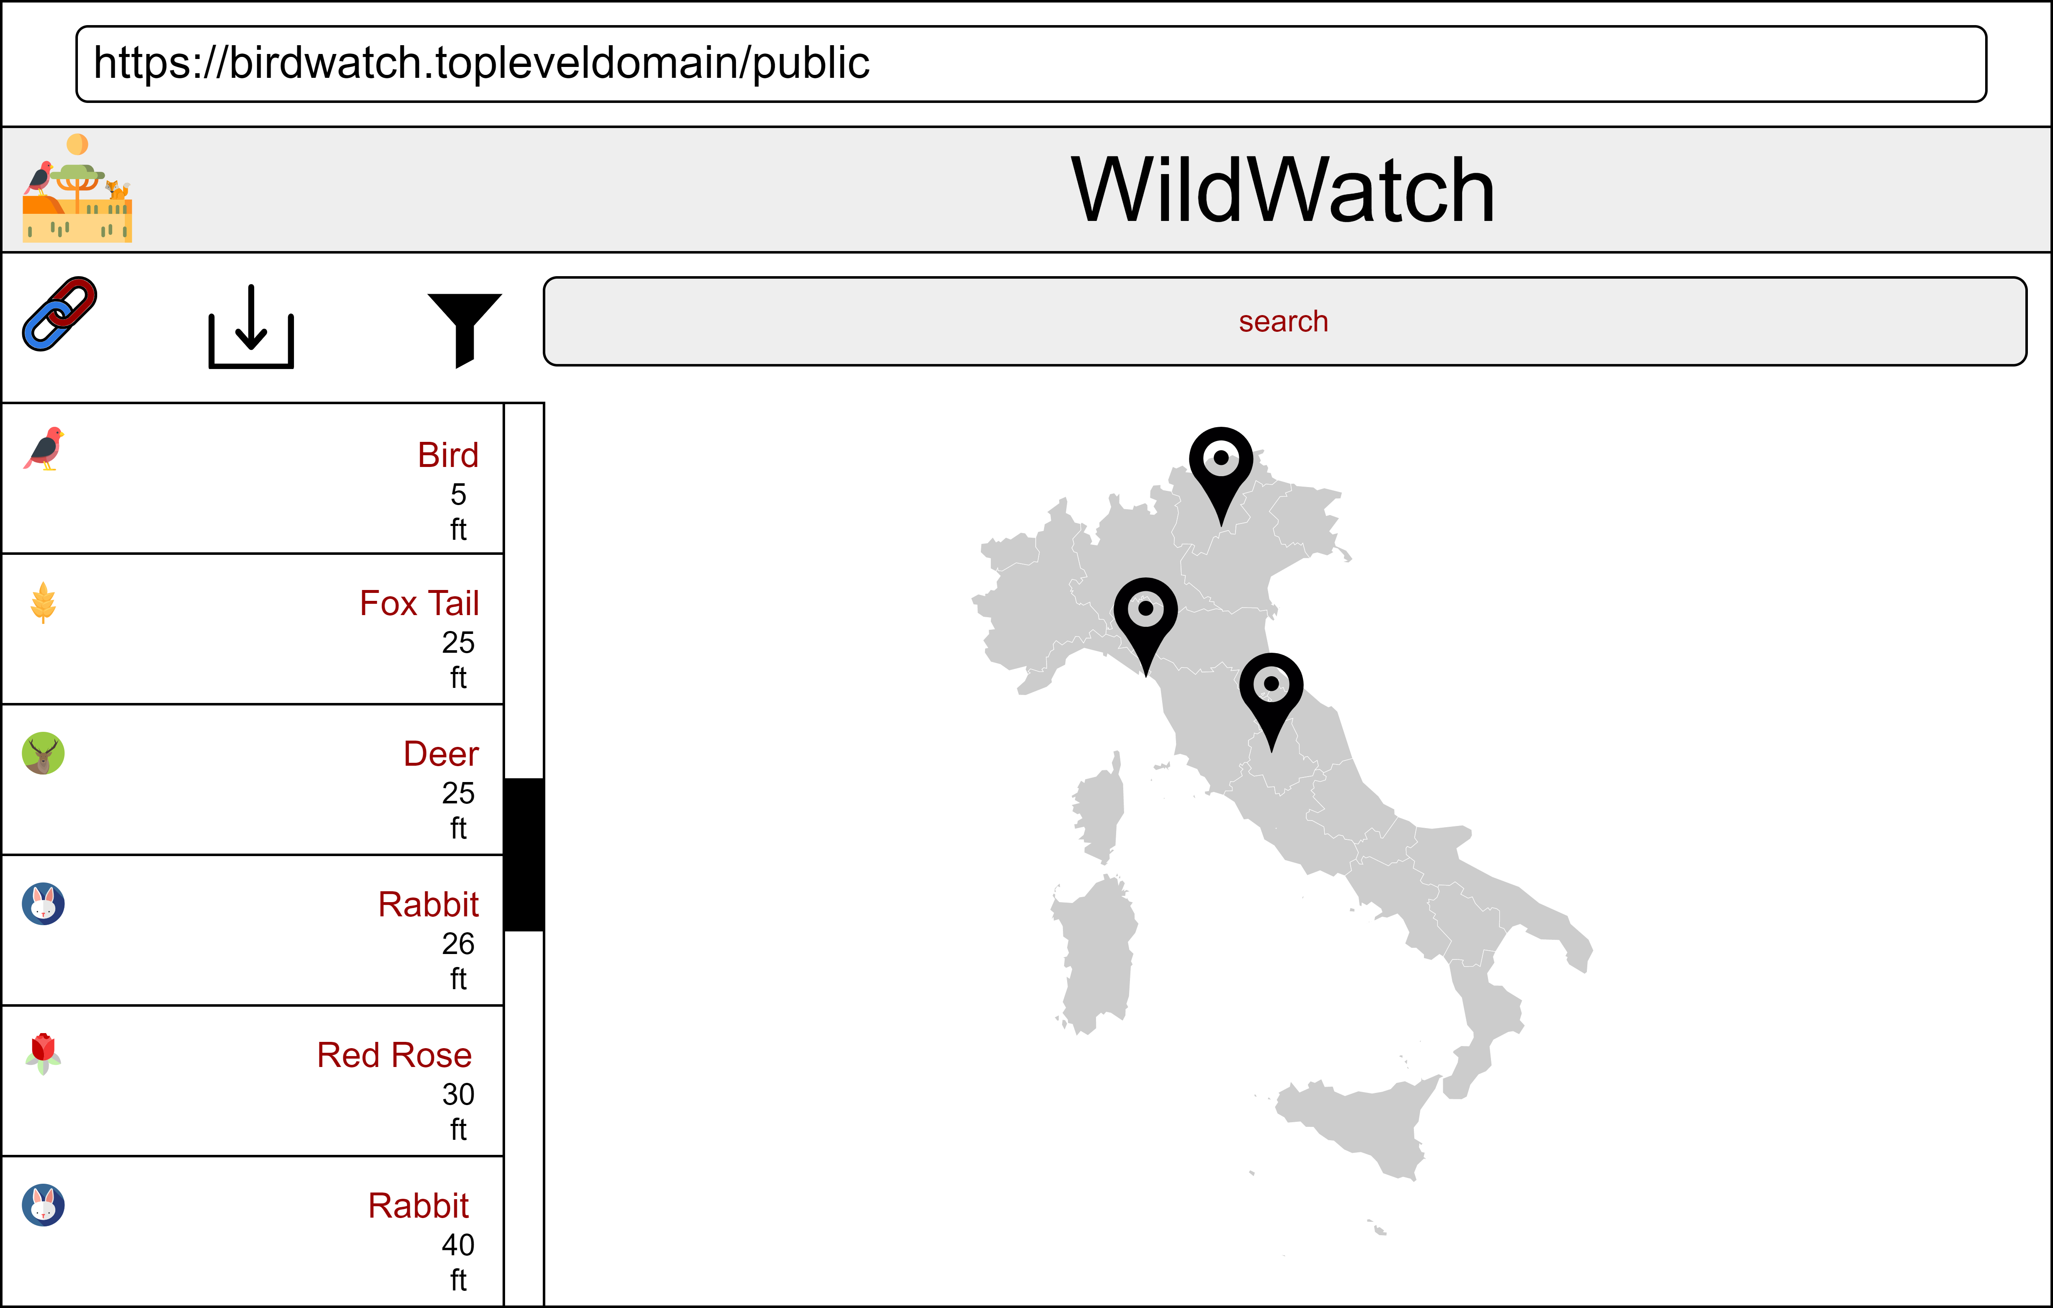

# Public Front End (Selection):



# Admin Front End (Home Page):

# Admin Front End (Selection):

# Project Overview (Swimlane Diagram):

